4Economic Questions
Student’s Name:
Institution of Affiliation:
Assignment
Q1
Explanation of trade deficit in the United States
According to Jackson, (2010) trade deficit or balance also known as net exports hints to economic predicament that materialize when a country exports less than it is exporting. It is calculated by deducting the amount of money cumulatively used in importing from the sum total amount of money generated from exports. It can either be negative, nearly equal or positive and is usually expressed in that particular country’s currency. The United States trade balance is the world largest and has been that way since 1975. The deficit in services and goods was $566 billion in 2017 whereby exports were $2.329 trillion against huge imports $2.895 trillion. The main exports were petroleum products and automobiles while exports majorly included food, automobiles and aircrafts.
Macroeconomic factors affecting trade balance
Usually, trade balance is influenced by factors that affect international trade including a country’s natural resource endowment, the various policies a country has on trade, inflation, foreign exchange reserves, and exchange rates among others. The United States of America is endowed with natural resources including copper, uranium, gold, nickel and many more which are all used in the manufacturing industries. However, due to bruising competition from other countries, these endowment is never fully exploited. Products from United States of America are considered much more expensive. It also has excellent human capital especially graduates from thee many world class universities across the country. They are key in proper and advanced service delivery.
Role proposed by current president will have on trade balance and potential side effects.
Kimberly, (2018) writes that President Donald Trumps announced earlier this year that to cope with such a huge trade deficit, the Unites States of America needs to embrace trade protectionism policies. This approach is meant to restrain unwarranted competition from companies in other countries. It is seen as a politically instigated move which is applicable only in the short run. Looking at it on a broader long term perspective, it is very wrecking in the sense that it makes local industries less combative in the international markets. Usually, there are four major ways of trade protection. They include tariffs on imports, subsidizing local manufactory, imposing quotas on imported goods and a less commonly known method which is devaluation of a countries currency to favor exports. The president proposed a 10% tariff on aluminum and a 25 percent tariff on steel which was after he imposed quotas on imported washing machines and solar panels. Analysts argue that such moves will only work in the short run since local industries will face reduced competition from imported goods. Imported goods becomes much more expensive because of the imposition of tariffs however, in the long run, it is very risky due to the possibility of currency wars. Each country that trades with the United States of America might opt to devalue their currencies against the US dollar which will only lead to a vicious cycle of who dominates the export markets. (Kimberly, 2018). Relationship between the United States of America and other allied countries will be at stake and can lead to further worsening of the trade balance.
Conclusively, trade deficit is a common inevitable occurrence in most of the countries and to a lower level, firms. The United States of America having being ranked as the country with the biggest trade balance for the longest time, is devastating considering the fact that it is a super power. My opinion is falls in line with that of Irwin, (2017) who posits that whatever policies that will be used, they be used wisely so as not to bring more havoc on the current and future trade deficits if there will be any.
Q2
When the oil prices increases, the cost business operation increases. This increased cost of production causes the firms to reduce their profits margin, for the firms to recap the profit the cost of production is transferred to the consumer by increasing the price, this leads to inflation. The high prices make the consumer to demand less thus the output produced by the firm reduces from Q1toQ2due to the increased cost of production. The firms may lay off workers due to the reduced production and increased cost of production. According to me, the most appropriate monetary policy for counteracting this change would be contractionary monetary policy. According to so and so, contractionary is used when the Federal Reserve slows economic growth to prevent inflation. Although it may sometimes be called restrictive monetary policy, it could be important when used when controlling oil market and the cost of business operations. Between monetary and fiscal policy, it would be more prudent to use fiscal policy when controlling prices oil and petroleum industry.

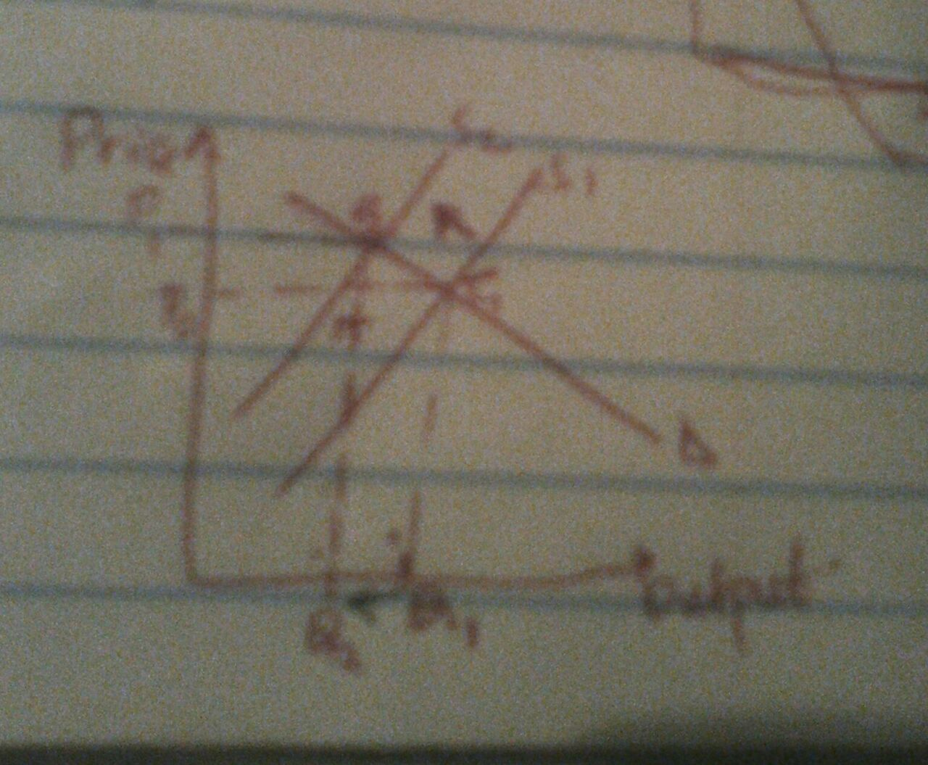
Q4
- Find the per worker production function

Y = K^{1/2} L ^{½}
Y = (K/L)^{1/2}
Let K/L be k ( per capita availability of a worker)
Then y = k^{1/2}

- Steady state level of capital per worker, steady state income per worker and steady state consumption per worker

At steady state;
Sf(k) = dk
d- depreciation rate
s- savings rate

in Kabukistan;
0.1k^{1/2} = 0.05k or k^{1/2} = 2
We compute k = 4 (Steady state level of capital per worker)
y= k^{1/2} = 0.2 -> ( steady state income per worker)
sy = 4 × 0.1 = 0.2
c= (4×0.4) = 1.8 -> (steady state consumption per worker)

in Raljon;
0.2k^{1/2} = 0.5 OR k^{1/2} = 4
We compute k = 16 (Steady state level of capital per worker)
y= k^{1/2} = 4 -> ( steady state income per worker)
sy = 4 × 0.2 = 0.8
c= (4×0.8) = 3.2 -> (steady state consumption per worker)

- Graph of the steady state
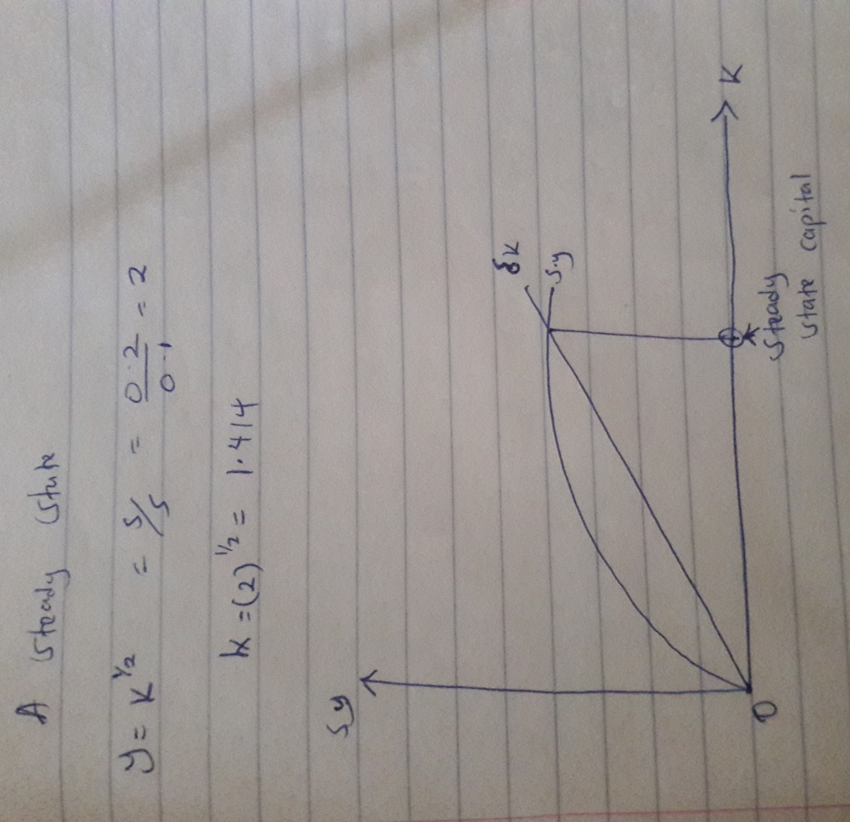
Question 5
- Foreigners, fearing uncertainty in the Asian financial markets start buying U.S. government bonds.
Savings - down
Investment - down
Trade balance - down
Interest rates –up
Exchange rates – down

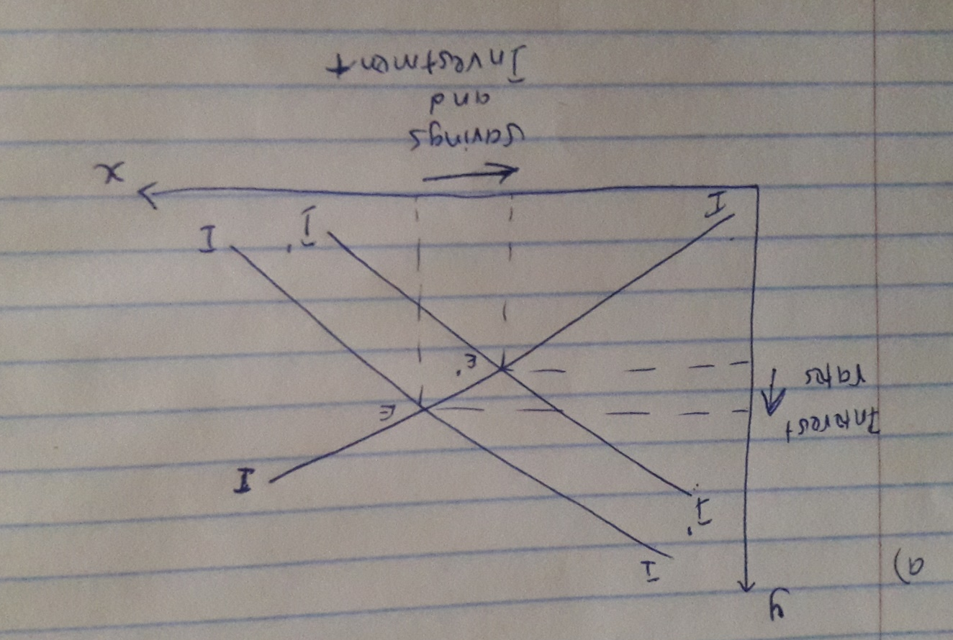

- In solidarity with Japan, the United States cut off trade with China.
Savings - down
Investment - down
Trade balance - down
Interest rates - up
Exchange rates – up
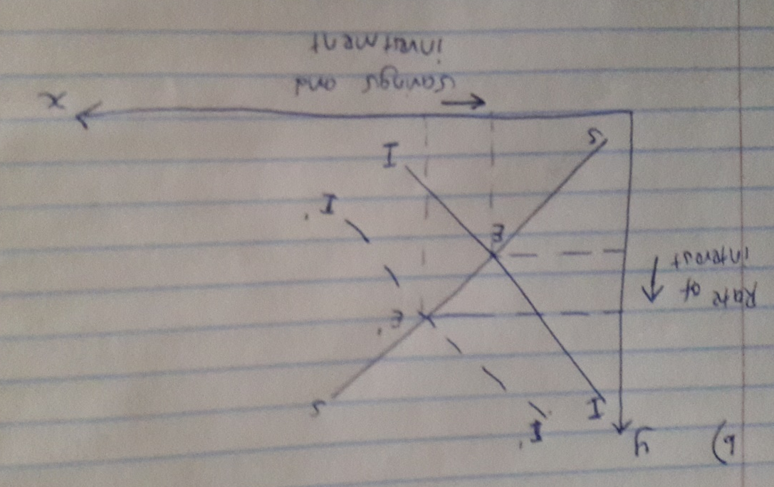

- Expecting Chinese made goods to be scarce, US firms seek resources to ramp up production of goods and services.
Savings - down
Investment - down
Trade balance - down
Interest rates - up
Exchange rates- down

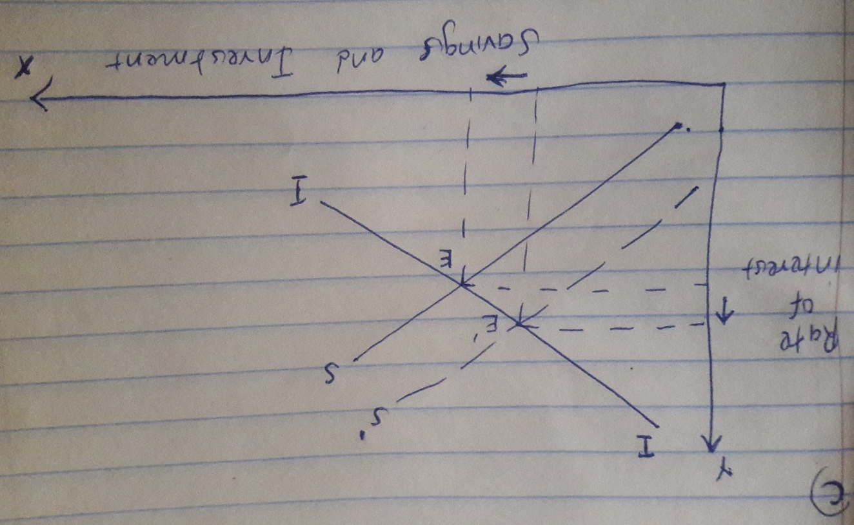

References
Irwin, D. A. (2017). Clashing over Commerce: A History of US Trade Policy. Chicago: University of Chicago Press.
Jackson, J. K., & Library of Congress. (2010). Financing the U.S. trade deficit. Washington, DC: Congressional Research Service, Library of Congress.
Kimberly, A. (2018). The U.S. Current Account Deficit – Threat or way of life? . Online source. Retrieved from: https://www.thebalance.com/the-u-s-current-account--deficit-threat-or-way-of-life-3305701

